CE magazine articles about trends in Telecoms and IT

Tech tutorial : match the words with their definition

MPLS (Multi-Protocol Label Switching) / Ethernet / Bandwidth / Wi-Max / 3G, 4G / SaaS / GSM (Global System for mobile communications) / Wi-Fi / Open source
_____________ : new generations of mobile phone standards, allowing mobile network operators to offer advanced services.
_____________ : a very high bandwith data networking technology used by companies in LANs (Local Area Network) and increasingly WANs (Wide Area Network).
_____________ :A worldwide standard for mobile phones making phones from one operator compatible with a different operator in another country.
_____________ : A data networking protocol and service that can carry different kinds of traffic-voice, data, video, etc.
_____________ : software that is made available to developers and users, licensed to encourage re-use without charge.
_____________: Software as a service
_____________ : a technology providing wireless transmission of data over a short range (for example, in a house or office).
_____________ : a technology providing wireless transmission of high speed data over a large area (for example, a city).
_____________ : a data tranfer rate
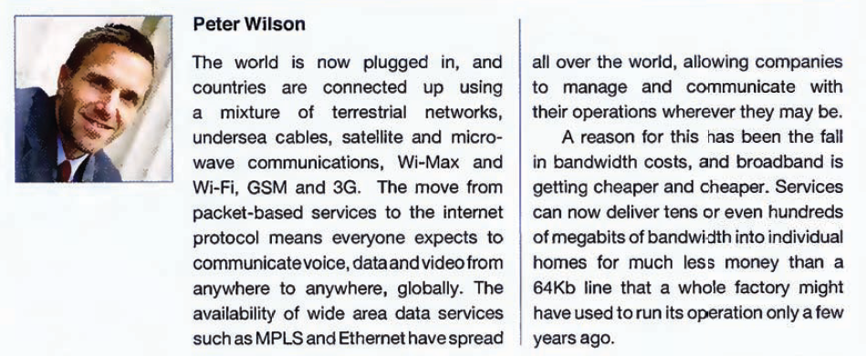
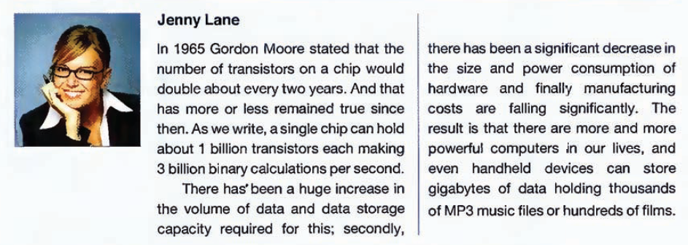
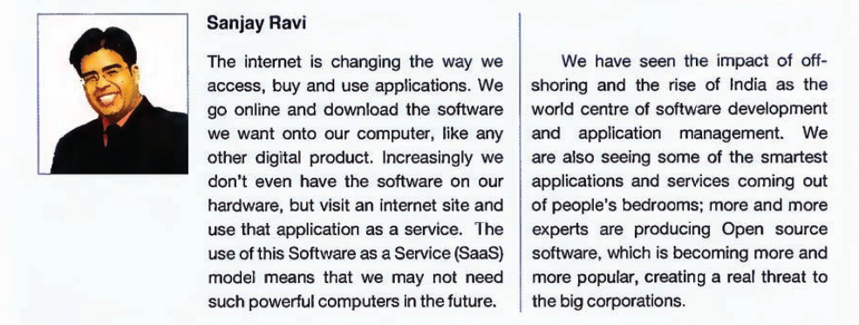
1. Match the industry leader to their area of expertise
Peter Wilson Software
Jenny Lane Telecoms
Sanjay Ravi Hardware

2. Read the article again, and say if the following statements are true or false. Justify with the text
According to Peter Wilson, a) most countries are connected up with undersea cables.
b) many countries have unreliable mobile phone networks.
c) recently bandwidth costs have risen dramatically.

According to Jenny Lane, a) Moore's predictions have been fairly accurate
b) a typical chip can now hold 3 billion transistors
c) Both data storage capacity and power consumption have gone up.

According to Sanjay Ravi, a) Fewer people are going to computer stores to buy software
b) SaaS will require ordinary users to have more powerful computers.
c) Software development needs the support of a big corporation to succeed.

3. Find the English words in the texts
silicium : _______________ données : ______________ bande passante : _______________ haut débit : ____________ réseau : _______________ puce : ____________
stockage : _____________ portable : _____________ logiciel : _____________
délocalisation : ______________ menace : _________________

4. Match the words on the left with the words on the right to make pairs that all often go together.
a. access A. chip, wafer, valley
b. download B. an application, a network, an account
c. go C. phone, telephony, broadband
d. mobile D. online, offline, on holiday
e. silicon E. a file, an image, a demo version

5. Complete the sentences using pairs of words from the previous exercise.
a) Everyone has _________________, so payphones are becoming redundant.
b) Many internet entrepreneurs from __________________, in California, are now turning their attention to alternative forms of energy.
c) Before you buy the program, you can __________________ just to see how you like it.
d) With a mobile broadband connection, you can ________________ any time and anywhere.
e) Internet banking allows users to ________________ and check their balances.
f) How many transistors can you fit onto a _______________ ?

6. Talking about change : use the right verb form and comparative form to express the actual change
a) Digital radio sets (become) __________________ (popular) _________________ .
b) (many) __________________ people (listen) _________________ to the radio over the internet.
c) Laptops (get) ______________ (cheap) ___________________ .
d) Handheld devices (become) __________________ (sophisticated) _____________.
e) Battery life (get) ___________________ long) ____________________ .
f) Mobile broadband speeds (increase) __________________ dramatically.

